[c# - Unable to copy a file from obj\Debug to bin\Debug - Stack Overflow](https://stackoverflow.com/questions/2625239/unable-to-copy-a-file-from-obj-debug-to-bin-debug)

[Unable to copy a file from obj\Debug to bin\Debug](https://stackoverflow.com/questions/2625239/unable-to-copy-a-file-from-obj-debug-to-bin-debug)

[Ask Question](https://stackoverflow.com/questions/ask)

Asked 11 years, 11 months ago

Active [27 days ago](https://stackoverflow.com/questions/2625239/unable-to-copy-a-file-from-obj-debug-to-bin-debug?lastactivity)

Viewed 184k times

Report this ad

63

17

I have a project in C# and I get this error every time I try to compile the project:

(Unable to copy file "obj\Debug\Project1.exe" to "bin\Debug\Project1.exe". The process cannot access the file 'bin\Debug\Project1.exe' because it is being used by another process.)

So I have to close the process from the task manager. My project is only one form and there is no multi-threading.

What is the solution (without restarting VS or killing the process)?

[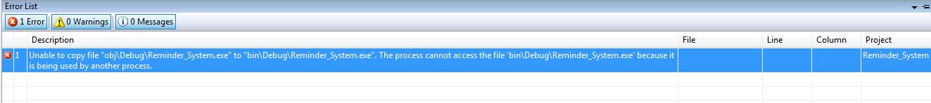](https://i.stack.imgur.com/150Ly.png)

[c#](https://stackoverflow.com/questions/tagged/c%23)[winforms](https://stackoverflow.com/questions/tagged/winforms)[visual-studio](https://stackoverflow.com/questions/tagged/visual-studio)

This should work.

Go to your project properties. Inside Build Events, under Pre-build event command line, add these two lines of code:

if exist "$(TargetPath).locked" del "$(TargetPath).locked"

if exist "$(TargetPath)" if not exist "$(TargetPath).locked" move "$(TargetPath)" "$(TargetPath).locked"

[Share](https://stackoverflow.com/a/30702871)

[Improve this answer](https://stackoverflow.com/posts/30702871/edit)

Follow

answered Jun 8, 2015 at 6:57

[[](https://stackoverflow.com/users/3694016/chaosifier)](https://stackoverflow.com/users/3694016/chaosifier)

[chaosifier](https://stackoverflow.com/users/3694016/chaosifier)

**2,207**2020 silver badges3737 bronze badges

* 1

Thank you, this works perfect. I had troubles with VS2013 PRO and VS2015 ENT. This fix solved the problem.

– [Volodymyr Prysiazhniuk](https://stackoverflow.com/users/1141423/volodymyr-prysiazhniuk)

[Oct 25, 2016 at 13:49](https://stackoverflow.com/questions/2625239/unable-to-copy-a-file-from-obj-debug-to-bin-debug#comment67745515_30702871)

* Awsome brother. Thanks a lot for helping to solve this headache error.

– [karan](https://stackoverflow.com/users/6007844/karan)

[Jan 28, 2019 at 12:06](https://stackoverflow.com/questions/2625239/unable-to-copy-a-file-from-obj-debug-to-bin-debug#comment95613739_30702871)